Steps to using GreenSeam Plus Pipe:
It is terrific that you are using the best snap lock pipe in the industry! GSI makes pre-sealed pipe and fittings; therefore, it contains the best sealant made from EPDM rubber and proprietary co-polymer. The sealant is located on the transverse and longitudinal seams.
Here are the steps to best install this ductwork:
Step 1: To start, have a pair of gloves on when working with metal pipe. You will want to grab a piece of pipe off its bundle by taking the top part of the non-crimped side and pulling it away from the rest of the bundle of pipe.
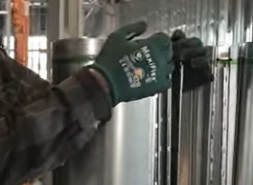

Step 2: You will want to snap the longitudinal side of the pipe together. Start with the beginning of the crimped side and fold the ends together into their seams.
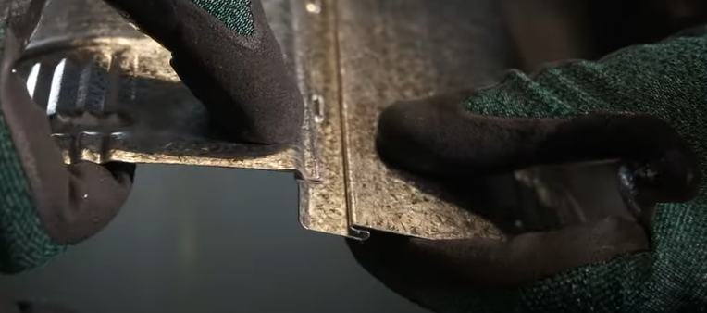

Step 3: Next you will fold the rest of the seams together and press down on the whole pipe with your two hands until you hear a pop noise. That sound is the key to you snapping the pipe together successfully.
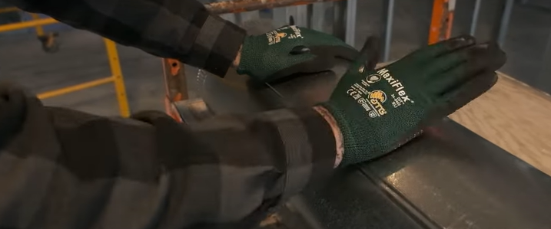
Step 4: After snapping the pipe together, you will want to take your hands inside the pipe and stretch out the pipe a little to make it rounder. You can also put your hands on the outside of the pipe and press into it to help create roundness.
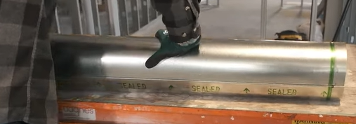
Step 5: When you put in the number of screws you need for the pipe, make sure to put them anywhere except for the Green Seam line. That line is where the gasket is located on the transverse seam.
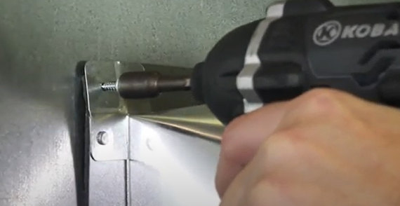
Step 6: Once you hang the pipe up in its elevated position, you will want to feed the pipe into the other pipes or fittings. In order to do this, take a pipe bent to a 45-degree angle and push it into the other pipe (male side into female side). You may have to use a little bit of force because of the sealant inside the transverse seam.
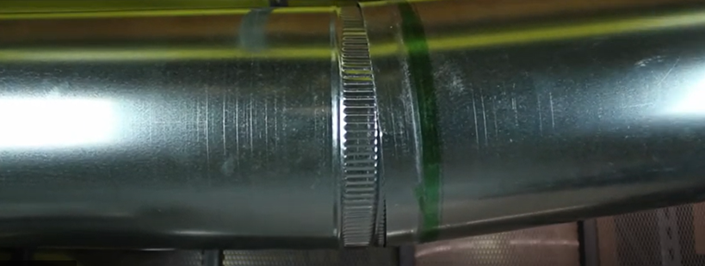
Step 7: Remember almost all our products are pre-sealed with the exception of: elbows (both 90-degree and 45-degree), reducers, and end caps. You can tell this by the GreenSeam line on our pipes and the green stickers on our fittings. Any of our products that are pre-sealed do not need outside duct sealant or masket.
